E-commerce Customer Journey & Conversion Funnel Analysis
Power BI Dashboard Documentation

1. Executive Summary
This project analyses the E-commerce customer journey from Page View to Purchase using click-stream data. The dashboard identifies conversion drop-off points, traffic source efficiency, and time delays between funnel steps to support data-driven business decisions.
- Project Goal: State the objective (e.g., "To visualize the E-commerce Customer Journey, identify key drop-off points, and analyse the performance of traffic sources over time.")
- Key Insight: The highest customer drop-off occurs between Add-to-Cart and Checkout, indicating friction related to pricing or shipping costs.
- Recommendation: Optimize cart and checkout experience by improving pricing transparency and testing free-shipping strategies.
2. Objective / Business Questions
* Identify key funnel drop-off stages
* Measure conversion rate by traffic source
* Analyse average time between funnel steps
* Identify geographical checkout friction
3. Project Overview and Data Sourcing
This section describes the foundation of your dashboard.
- Dashboard Title: "E-commerce Customer Journey & Drop-off Conversion Funnel Analysis Report"
- Target Audience: Marketing Team, Product Managers, Executive Leadership.
- Data Source(s): CSV files (Customers, session, source, product, Events).
- Data Preparation & Cleaning: Removed invalid session records, Standardized timestamps, Created Date table for time analysis,
Validated event sequences per session
Tools Used: Power BI, Power Query, DAX

4. Data Model Design (The Schema)
- Schema: Star Schema
- Fact Table: Clickstream Events
- Dimensions: Date, Traffic Source, Product, Country
- Relationships ensure accurate time intelligence and filtering

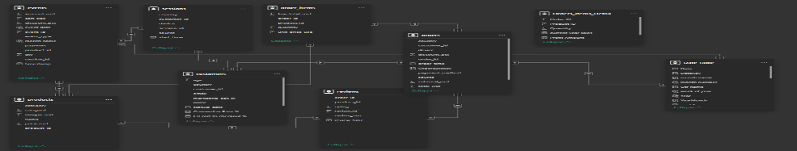

5. Key Performance Indicators (KPIs)
- Total Sessions
- Total Purchases
- Conversion Rate (%)
- Funnel Step Drop-off (%)
- Avg Time:
- age View → Add to Cart
- Add to Cart → Checkout → Checkout → Purchase

6. Visualizations and Analysis
Main Funnel Visual: Shows the sequence of steps (Page_View >> Add_to_Cart>> Checkout >> Purchase) and clearly highlights the highest percentage drop-off step, and it’s shows with conversion rate % previous step all steps.
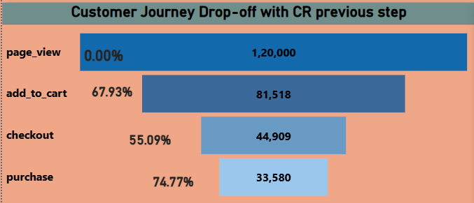
Traffic Source Performance Chart: Stacked Bar chart its showing stage wise total volume by Traffic Source (e.g., Organic, Paid, Social). Identifies which source is most/least efficient.
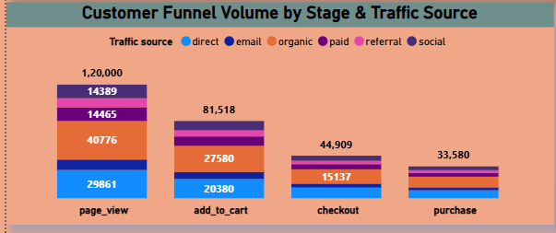
Dynamic Trend Chart: Line chart showing Traffic source CR over Time. Allows the user to select any induvial source to track the performance trend.
Map Chart: Map chart showing CR from Add_to_card to Checkout by country wise. Is that end user can see where CR % higher it like RED colour , that country need focus and reduce shipping cost …
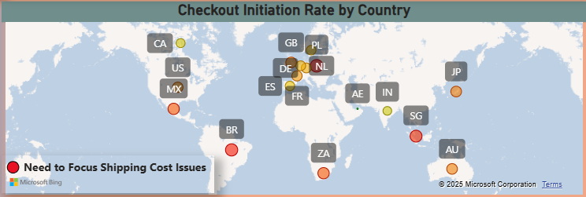

7. Insights & Findings
- Add-to-Cart → Checkout is the biggest friction point
- aid traffic shows higher conversion efficiency
- Certain countries show higher checkout abandonment
- Longer checkout times correlate with lower conversion
8. Business Recommendations
- Simplify checkout flow
- Reduce shipping cost surprises
- Optimize high-performing traffic channels
- Improve experience for high drop-off regions

9. Conclusion
This dashboard enables stakeholders to:
- Understand customer behaviour
- Detect conversion bottlenecks
- Make faster, data-driven decisions

